Angewandte Physik und Messtechnik, LRT 2
Prof. Dr. Günther Dollinger
14.11.2014

Master Thesis

Advancement of Proton Microchannel Radiotherapy
at the ion microprobe SNAKE

Proton microchannel radiotherapy, a spatially fractionated radiotherapy approach using micrometer-sized proton beams which spread out into the tumor to homogeneously irradiate the cancer cells was recently invented at the ion microprobe SNAKE in Munich. The goal of this irradiation method is to minimize the risk of normal tissue damage by sparing large areas of the normal tissue, especially close to the skin, while preserving local tumor control through a homogeneous irradiation of the tumor.
The scope of this thesis is the continuation of the studies on proton microchannel therapy with regard to potential implementation in a radiotherapy facility. A systematic investigation of the role of channel size and distance is therefore of crucial importance to define the extent of the required technical developments. The work is performed in strong cooperation with the radiation oncology department of the Klinikum Rechts der Isar within the cluster of excellence MAP.

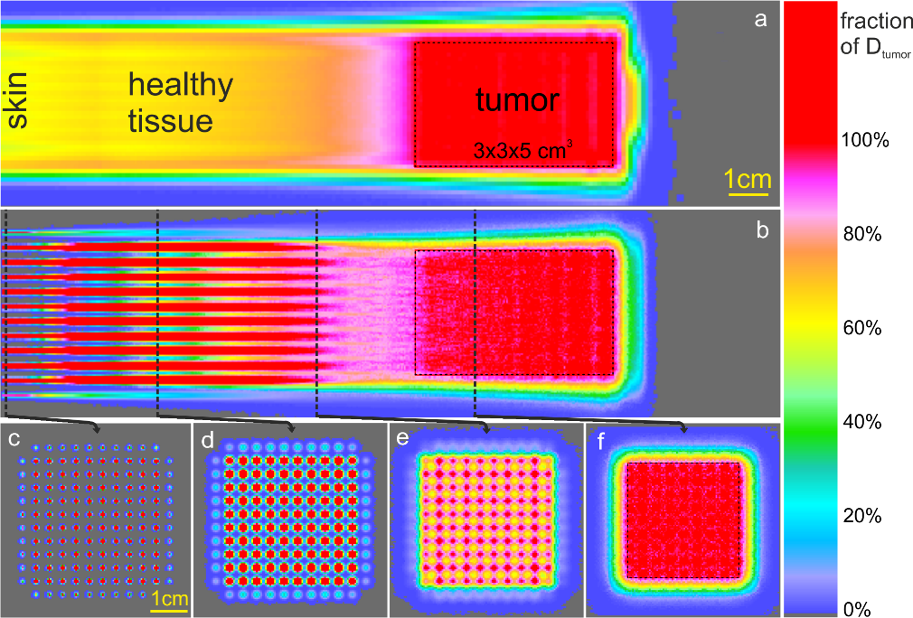
Dose distributions for homogeneous and microchannel proton irradiation. The tumor is situated at 10.6–15.6 cm depth and is irradiated homogeneously with a dose D_{tumor} (=100% on the color bar) by homogeneous (a) or microchannel (b) proton irradiation from one direction (beams from the left).

